Parameterized Jenkins Job –Documentation

Objective
The objective of this task is to create a simple parameterized Jenkins job to understand how Jenkins parameters work, how values are passed during build time, and how they are used inside a shell command.

Steps Performed

Step 1 — Login to Jenkins
- Open Jenkins in the web browser.
- The Jenkins login page appears.
- Enter:
  - Username: admin
  - Password: Admin@321
- Click on Sign in.
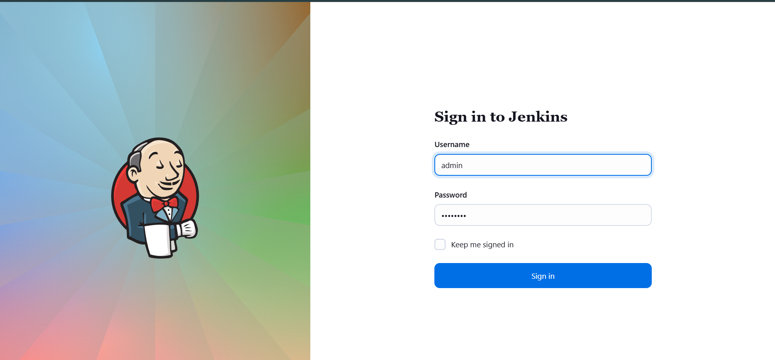

Step 2 — Create a New Job
- After successful login, the Jenkins Dashboard is displayed.
- Click on New Item from the top menu.
- In the “Enter an item name” field, type:
- parameterized-job
- Select Freestyle project.
- Click OK.
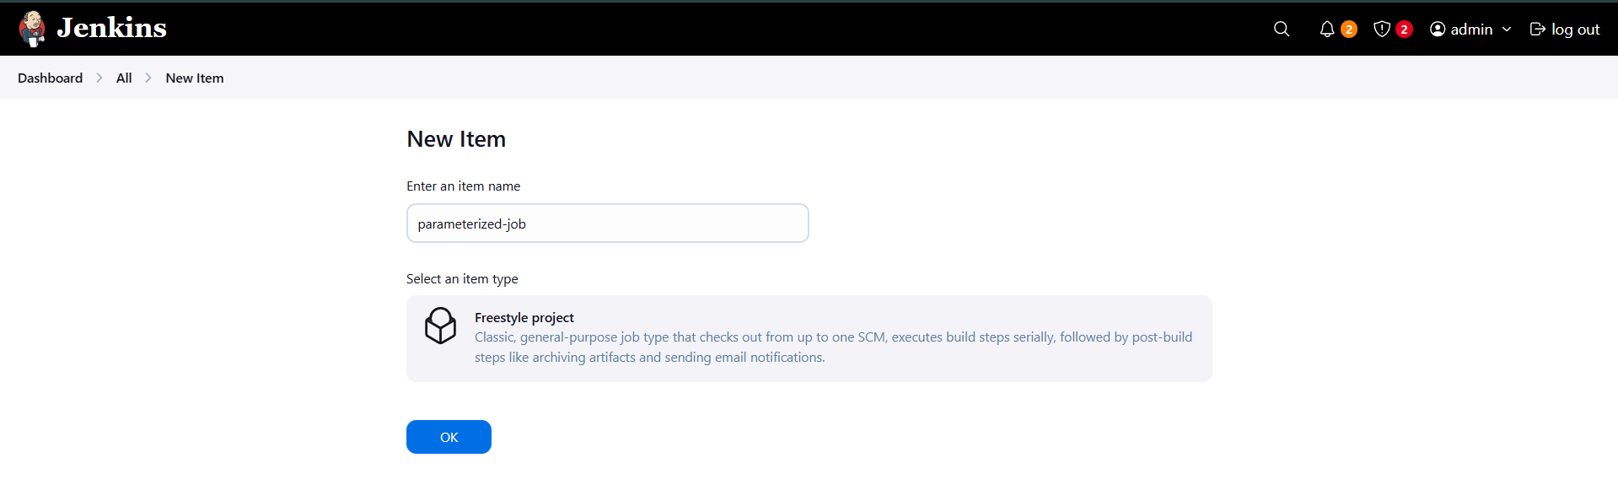

Step 3 — Enable Parameterized Job
- The job configuration page opens.
- Check the box This project is parameterized.

Step 4 — Add String Parameter
- Click on Add Parameter.
- Select String Parameter.
- Enter the details:
- Name: Stage
- Default Value: Build
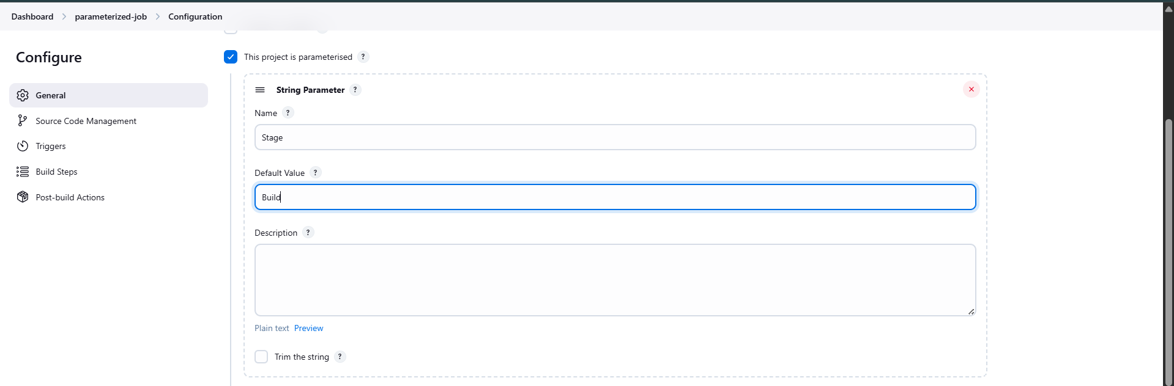

Step 5 — Add Choice Parameter
- Click again on Add Parameter.
- Select Choice Parameter.
- Enter the details:
- Name: env
- Choices:
  - Development
  - Staging
  - Production
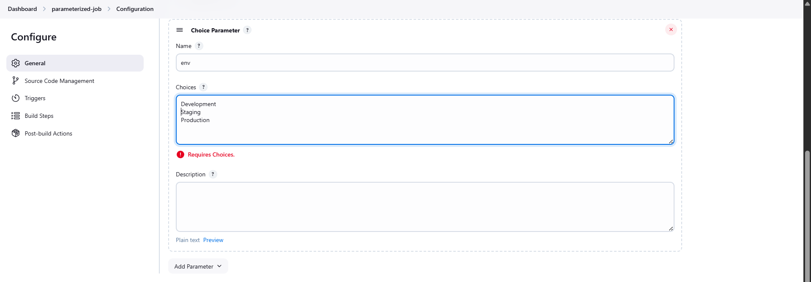

Step 6 — Add Build Step (Execute Shell)
- Scroll down to Build Steps.
- Click on Add build step → Select Execute shell.
- In the command box, type:
echo $Stage $env
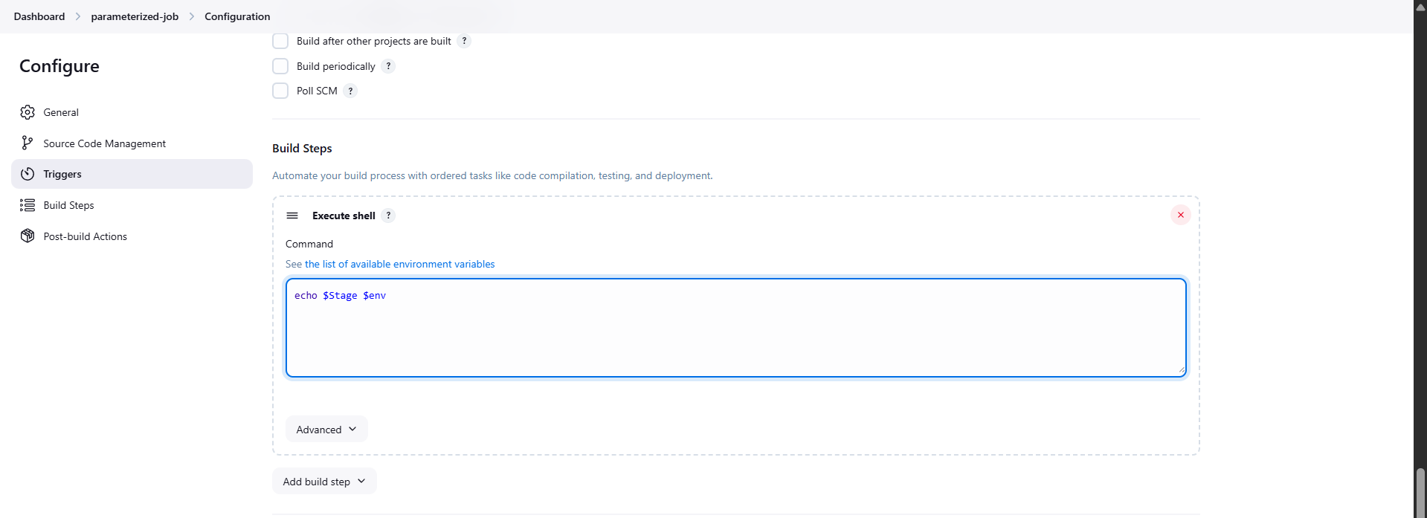

Step 7 — Save the Job
- Click on Save at the bottom of the page.
- The job parameterized-job is created successfully.

Step 8 — Build the Job with Parameters (First Run – Staging)
- Click on Build with Parameters from the left panel.
- Set the parameters:
- Stage: Build
- env: Staging
- Click on Build.
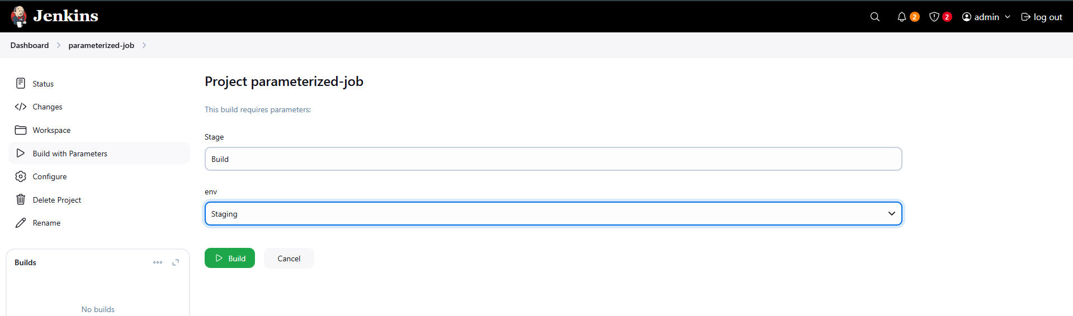

Step 9 — Check Console Output (Staging)
- Click on Build #1.
- Click on Console Output.
- Verify that the output shows:
Build Staging
- The build status should be SUCCESS.
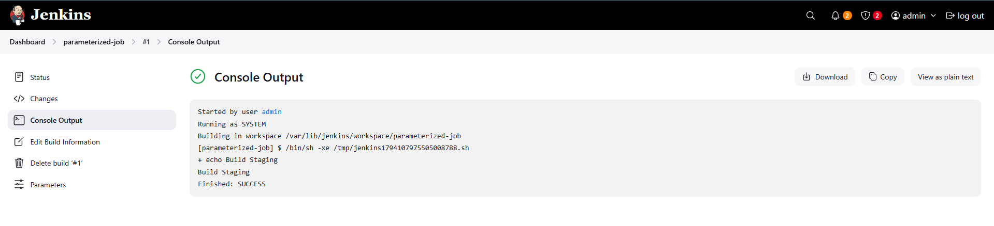

Step 10 — Build Again with Development
- Click again on Build with Parameters.
- Select:
- Stage: Build
- env: Development
- Click Build.
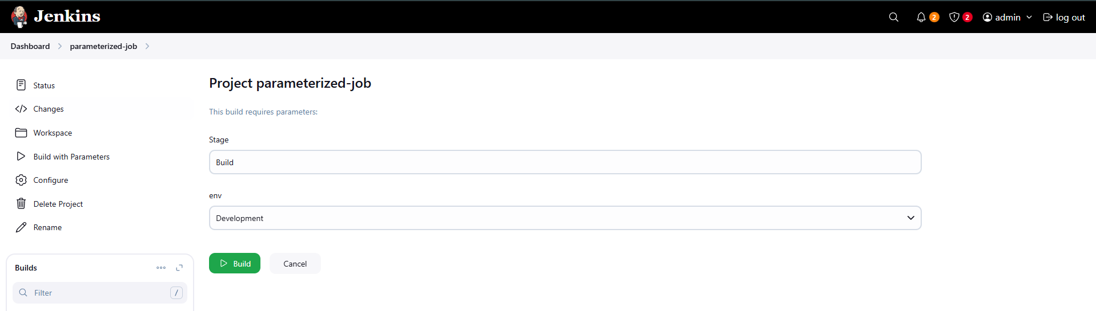

Step 11 — Check Console Output (Development)
- Open the new build.
- Check Console Output.
- Verify output:
Build Development
- Build status should be SUCCESS.
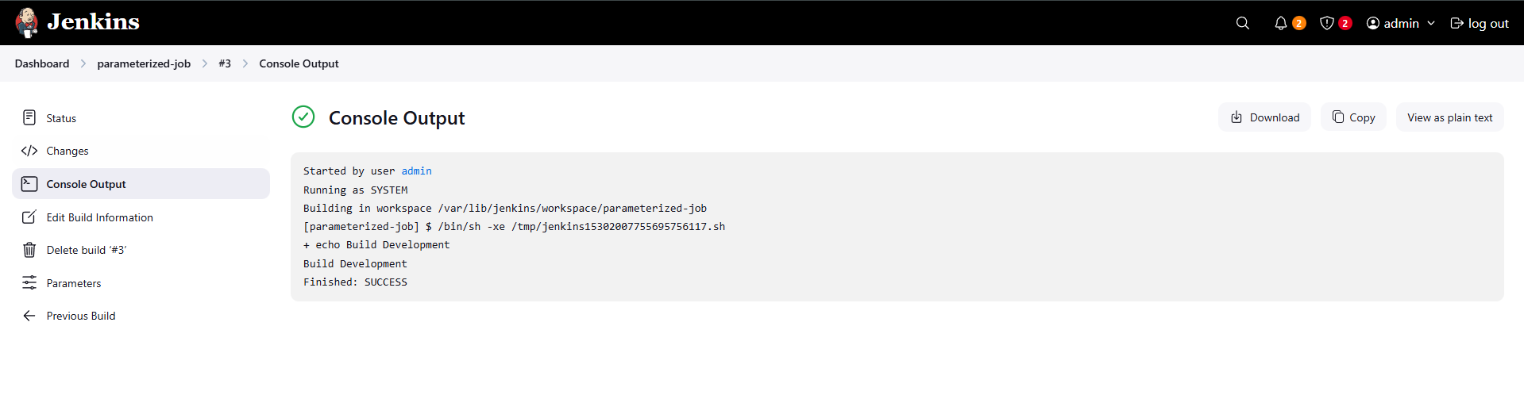

Step 12 — Build Again with Production
- Click on Build with Parameters.
- Select:
- Stage: Build
- env: Production
- Click Build.
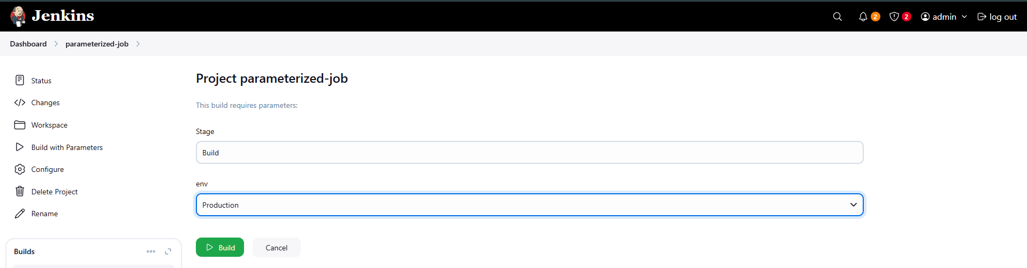

Step 13 — Check Console Output (Production)
- Open the latest build.
- Click on Console Output.
- Verify output:
Build Production
- Build status should be SUCCESS.
